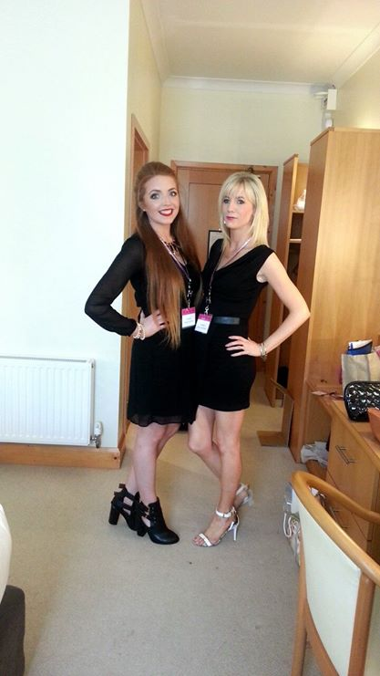
Self-motivated and well-organised, strong and effective interpersonal, leadership and communication skills. Great ability to work and adapt to a changing environment whilst working under pressure and proven high standards of work. Reliable, approachable and friendly.

Personal Details:
Name: Michelle Fox
Address: Carrowhubbock,
Enniscrone,
Co. Sligo.
Telephone: 087-3633301
E-mail: foxym30@hotmail.com

Education:
Primary School: Enniscrone National School,
1982-1991 Main Street,
Enniscrone,
Co. Sligo.
Secondary School:Jesus&Mary Secondary School,
1991-1997 Enniscrone,
Co. Sligo.

Examinations:
- Junior Certificate 1994
- Leaving Certificate 1997
Leaving Certificate 1997
Subject | Level | Grade
English | Higher | C
Maths | Higher | B
History | Higher | B
Geography | Ordinary | B
Home Economics | Higher | B
Business Studies | Ordinary | C
Art, Craft, Design | Ordinary | B
Gaeilge | Ordinary | C

Achievements:
- 2014: Organised a Charity Fashion Show in aid of Pieta House and The Irish Cancer Society.
- 2014: Offered the managerial position of Sara Boutique.
- 2012: Became member of The Gospel Choir of Ballina.
- 2011, 2012 & 2013: Won first place in the “Axe Factor” charity event in aid of Enniscrone National School.
- 2010: Achieved my Full Driver’s License.
- 2008: Began participating in The Enniscrone Church Choir.

Skill Set:
- I will ensure best levels of customer care are delivered at all times.
- I have an ability to effectively deal with customer queries in a friendly and efficient manner.
- I am flexible with regards to duties and hours of work/shifts in the workplace.

Employment:
Connaughton’s Newsagents
Main Street,
Enniscrone,
Co. Sligo.
Shop Assistant
June 1995-August 1997

My Responsibilities at Connaughton’s Newsagents include:
- Stock rotation of products.
- Dealing with money using the cash register.
- Cleaning the shop.

Royal Dragon Chinese
Main Street,
Enniscrone,
Co. Sligo.
Shop Assistant
April 2003-April 2004

My Responsibilities at Roy al Dragon Chinese include:
- Serving customers.
- Working on the tills.
- Answering phones.
- Taking orders.
- Cashing the tills and prepared float.

Spar Grocery Store
Main Street,
Enniscrone,
Co. Sligo.
Shop Assistant
June 2004-September 2004

My Responsibilities at Spar Grocery Store include:
- Stock rotation of products.
- Dealing with money using the cash register.
- Cleaning the shop.
- Working in the deli.

Sara Boutique
Bridge Street,
Ballina,
Co. Mayo.
Shop Assistant
October 2011-Present

My Responsibilities at Sara’s Boutique include:
- Working on the tills.
- Dealing with customers.
- Cleaning the shop.
- Stock taking.
- Merchandising.
- Merchandising display windows.

Ocean Sands Hotel
Main Street,
Enniscrone,
Co. Sligo.
Waitress
May 2010-May 2011

My Responsibilities at Ocean Sands Hotel include:
- Housekeeping.
- Waitressing.
Diamond Coast Hotel
Main Street,
Enniscrone,
Co. Sligo.
Waitress
August 2007-January 2009

My Responsibilities at Diamond Coast Hotel include:
- Working at wedding receptions and special occasions.
- Helping in the kitchen.

Referees:
Mary Clarke Kathryn Wharfe,
Manager CEO of Sara Boutique
The Diamond Coast Hotel Sara Boutique,
Bartra, Bridge Street,
Enniscrone, Ballina,
Co. Sligo. Co. Mayo.
096-26022 096-73979

Signed: ____________________ Date: ________________

